1. **Difference between Electric Vehicle Battery System and Energy Storage System**

**From an EV design engineer’s perspective, the key difference lies in *performance demands and system integration*: EV battery systems prioritize high power density, fast discharge, and compact packaging for mobility, while energy storage systems (ESS) focus on long-duration energy delivery, scalability, and grid-level stability.**

* Core Differences: EV Battery vs Energy Storage System (ESS)

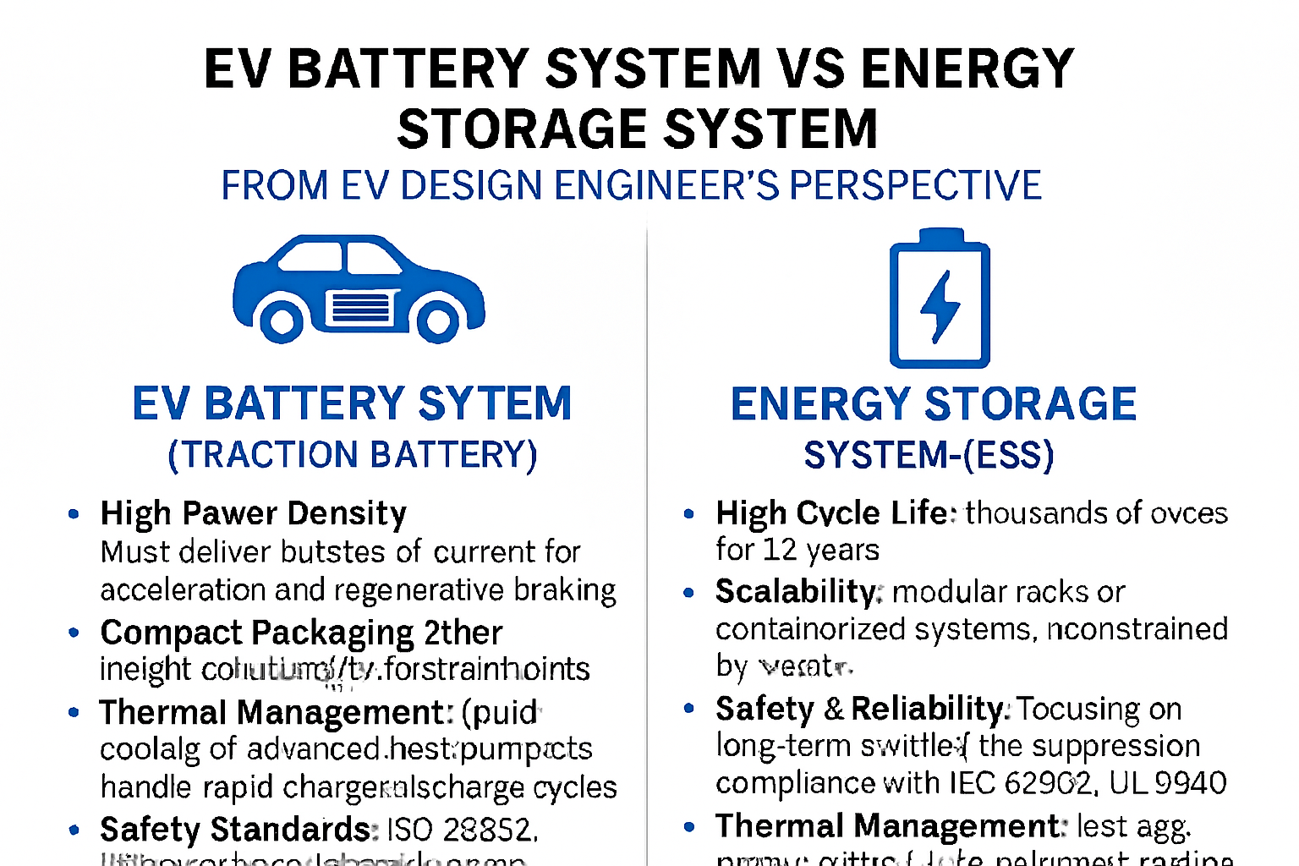

* Design Engineer’s Perspective

As an EV design engineer, here’s how you’d approach each system:

* EV Battery System
* **Design Constraints**: Must fit within vehicle chassis, meet crash safety, and support regenerative braking.
* **Validation Focus**: HIL testing for drive cycles, thermal stress, and fault injection.
* **BMS Role**: Real-time SOC/SOH estimation, cell balancing, thermal protection, and CAN-based diagnostics.
* **Optimization Goals**: Maximize range, minimize weight, ensure fast charging, and maintain performance across temperature extremes.
* **ESS Battery System**
* **Design Constraints**: Stationary setup allows for larger footprint and relaxed weight constraints.
* **Validation Focus**: Long-duration cycling, grid compliance, and EMS integration.
* **BMS Role**: Focused on longevity, charge/discharge scheduling, and predictive maintenance.
* **Optimization Goals**: Cost per kWh, cycle life, safety under prolonged use, and scalability.
* Key Engineering Trade-offs
* **Thermal Management**: EVs require dynamic thermal control (liquid cooling, heat pumps), while ESS may use passive or HVAC-based systems.
* **Cell Chemistry Choices**: EVs often use NMC or NCA for energy density; ESS may prefer LFP for safety and cycle life.
* **Control Architecture**: EV batteries are tightly coupled with vehicle control units; ESS batteries interface with EMS and grid converters.

## **EV Battery System (Traction Battery)**

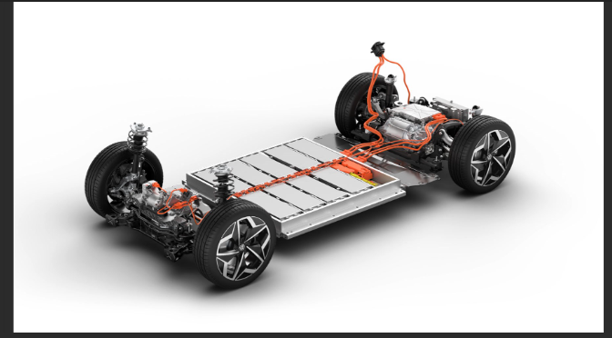

Source: http://evmagz.com/6-types-of-electric-vehicle-batteries-you-need-to-know/

* **Purpose**: Provides propulsion energy to drive the vehicle.
* **Design Priorities**:
  + **High Power Density** → must deliver bursts of current for acceleration and regenerative braking.
  + **Compact Packaging** → integrated into chassis, with strict weight and volume constraints.
  + **Thermal Management** → liquid cooling or advanced heat pumps to handle rapid charge/discharge cycles.
  + **Safety Standards** → ISO 26262, UN38.3, IEC 62660 for automotive compliance.
* **Chemistry Choices**: NMC/NCA for high energy density; LFP for safety and cost in mass-market EVs.
* **BMS Role**: Real-time SOC/SOH estimation, fault detection, CAN-based communication with VCU, and fast balancing.

## **Energy Storage System (ESS)**

Battery energy storage systems (BESS), also called rechargeable battery systems, are an advanced technological solution that allows the storage of energy in multiple ways for later use. BESS consists of one or more batteries and can be used to balance the electric grid, provide backup power and improve grid stability. This stored energy can then be drawn upon when needed to meet various demands for power across different applications.

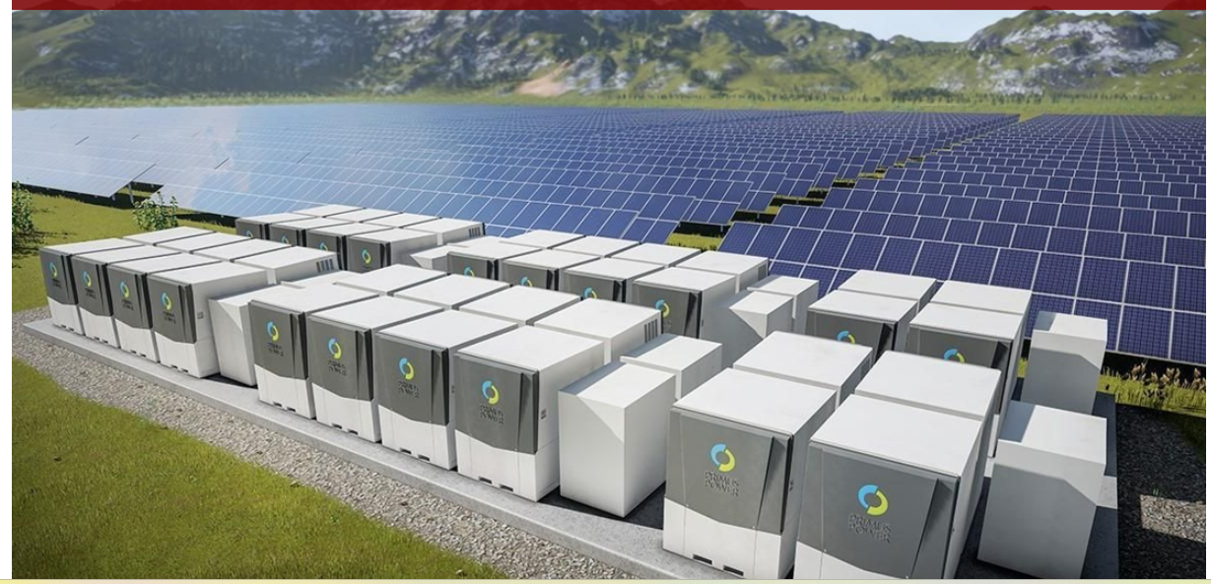

* **Purpose**: Stores electricity for grid stabilization, renewable integration, or backup power.
* **Design Priorities**:
  + **High Cycle Life** → thousands of cycles over 10–15 years.
  + **Scalability** → modular racks or containerized systems, not constrained by weight.
  + **Safety & Reliability** → focus on long-term stability, fire suppression, and compliance with IEC 62933, UL 9540.
  + **Thermal Management** → less aggressive, often HVAC or passive cooling.
* **Chemistry Choices**: LFP dominates due to safety, long cycle life, and cost-effectiveness.
* **BMS Role**: Long-term health monitoring, predictive maintenance, and integration with EMS/grid converters.

## **Engineer’s Perspective: Key Trade-offsfs**

* **Performance vs Longevity**:

EV batteries → prioritize *instantaneous power and compactness*.

ESS → prioritize *durability, cost per kWh, and scalability*.

* **Integration**:

EV → tightly coupled with vehicle control units (VCU, inverter, CAN).

ESS → integrated with grid systems (EMS, PCS, SCADA).

* **Validation Focus**:

EV → drive cycles, crash safety, fast charging validation.

ESS → long-duration cycling, grid compliance, fault-tolerant operation.

* In short: **EV batteries are like sprinters — fast, compact, and powerful. ESS batteries are marathon runners — steady, scalable, and built for endurance.**

Would you like me to create a **MATLAB/Simulink-style block diagram comparison** (EV battery vs ESS architecture) so you can visualize the differences in system integration?

|  |  |  |
| --- | --- | --- |
| **Feature** | **EV Battery System** | **Energy Storage System (ESS)** |
| **Primary Purpose** | Powering electric vehicles for mobility | Storing energy for grid, home, or industrial use |
| **Discharge Characteristic** | High discharge rate for acceleration and torque | Controlled discharge over long durations |
| **Energy Density** | High energy and power density in compact form | Moderate energy density, optimized for capacity and safety |
| **Thermal Management** | Aggressive cooling/heating for dynamic load cycles | Passive or active cooling for stable operation |
| **Cycle Life Expectation** | ~1000–2000 cycles (optimized for performance) | ~5000+ cycles (optimized for longevity) |
| **Packaging & Form Factor** | Lightweight, compact, modular (e.g., pouch, prismatic) | Larger, scalable racks or containers |
| **BMS Focus** | Real-time monitoring for safety, performance, and range | Long-term health, balancing, and grid compliance |
| **Integration** | Tied to vehicle architecture, CAN protocols, VCU, etc. | Integrated with EMS, PCS, and grid converters |
| **Safety Standards** | ISO 26262, UN38.3, IEC 62660 | IEC 62933, UL 9540, IEEE 1547 |

References:

[EV battery vs storage battery - the specific differences analysis - TYCORUN ENERGY](https://www.takomabattery.com/ev-battery-vs-storage-battery/)

[Differences Between EV Battery Packs and Storage Battery Packs | LinkedIn](https://www.linkedin.com/pulse/differences-between-ev-battery-packs-storage-ricky-luo-juhuc/)

[EV vs ESS Battery: Key Differences & Thermal Management - Trumonytechs’](https://www.trumonytechs.com/ev-vs-ess-battery/)

<https://brickstone.africa/what-are-battery-energy-storage-systems/>

1. **Why Lithium Ion Batteries are Better than Lead Acid Batteries**

**Lithium-ion batteries are preferred in EV design because they offer the best balance of energy density, efficiency, compactness, and reliability — enabling longer range, faster acceleration, and safer packaging within tight vehicle constraints.**

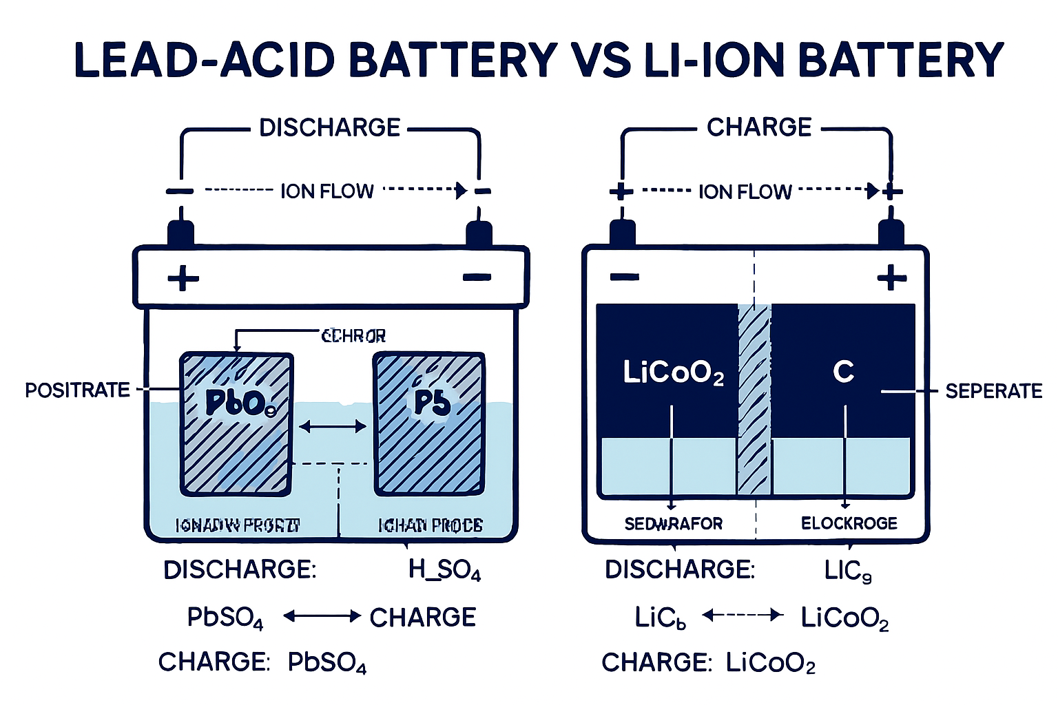

**Lead-Acid Battery** and **Lithium-Ion Battery** side-by-side, showing:

* **Internal anatomy**: electrodes, separator, electrolyte
* **Ion flow**: H⁺ and SO₄²⁻ in lead-acid; Li⁺ in lithium-ion
* **Electron flow**: through external circuit during discharge
* **Chemical reactions**:
* Lead-Acid:

**Discharge** → Pb + PbO₂ + 2H₂SO₄ → 2PbSO₄ + 2H₂O

**Charge** → reverse reaction

* Lithium-Ion:

**Discharge** → LiC₆ + LiCoO₂ → C₆ + LiCoO₂ (Li⁺ intercalates into cathode)

**Charge** → reverse reaction

The image uses color-coded arrows and clean labels to make the electrochemical processes clear and project-ready. You can click/open the card above to view and download it.

## **Why Lithium-Ion Batteries Dominate EV Design**

From an EV design engineer’s perspective, lithium-ion (Li-ion) batteries are chosen not just for their chemistry, but for how they align with the *performance, packaging, and lifecycle demands* of electric vehicles:

### **1. High Energy Density**

* **Justification**: Li-ion cells store more energy per unit mass and volume than alternatives like NiMH or lead-acid.
* **Design Impact**: Enables longer driving range without increasing battery size or weight — critical for compact EVs and range-sensitive applications.

### **2. High Efficiency**

* **Justification**: Li-ion batteries have round-trip efficiencies of 90–95%, meaning minimal energy loss during charge/discharge.
* **Design Impact**: Improves overall vehicle energy utilization, supports regenerative braking, and reduces thermal losses.

### **3. Compact Size & Lightweight**

* **Justification**: High energy-to-weight ratio allows for sleek battery pack designs.
* **Design Impact**: Facilitates underfloor integration, lowers center of gravity, and frees up cabin space — essential for modern EV architecture.

### **🔧 4. Low Maintenance**

* **Justification**: Li-ion cells are sealed, require no water topping, and have no memory effect.
* **Design Impact**: Reduces service complexity and cost, especially in consumer EVs where reliability and ease of use are paramount.

### **5. Low Self-Discharge**

* **Justification**: Li-ion batteries lose only ~1–2% of charge per month when idle.
* **Design Impact**: Supports long-term storage, showroom readiness, and minimal parasitic drain — ideal for fleet and consumer EVs.

## **Additional Engineering Advantages**

|  |  |
| --- | --- |
| **Feature** | **EV Design Benefit** |
| **High Cell Voltage** | Fewer cells needed → simpler pack design |
| **Thermal Stability** | Easier to manage with liquid cooling systems |
| **Cycle Life** | 1000–2000 cycles → supports 8–10 year warranties |
| **Modular Form Factor** | Pouch, prismatic, cylindrical → flexible integration |

Sources: [E-Vehicle Info](https://e-vehicleinfo.com/why-lithium-ion-batteries-used-in-electric-vehicles/), [MIT Climate Portal](https://climate.mit.edu/ask-mit/why-are-lithium-ion-batteries-and-not-some-other-kind-battery-used-electric-cars-and-grid)

**3. Discharge C rate of the battery whose capacity is 50 Ah and the discharge current is 120 Ampere**

**The discharge rate of a battery, from a battery engineer’s perspective, defines how quickly stored energy is delivered to a load — and is critical for optimizing performance, thermal behavior, and cycle life in EV systems. It’s typically expressed as a C-rate.**

What Is Discharge Rate?

* **Definition**: The discharge rate is the **rate at which current is drawn from a battery**, relative to its rated capacity.
* **Formula**:

\mathrm{Discharge\ Rate\ (C)}=\frac{\mathrm{Discharge\ Current\ (A)}}{\mathrm{Battery\ Capacity\ (Ah)}}

* Example: A 50 Ah battery discharging at 100 A → **2C rate**

Battery Engineer’s Perspective

1. **C-Rate as a Design Parameter**

* **1C** → full discharge in 1 hour
* **2C** → full discharge in 30 minutes
* **0.5C** → full discharge in 2 hours
* Engineers use C-rate to **simulate real-world load profiles**, especially in EVs where acceleration demands high current bursts.

2. **Thermal Management**

* **Higher discharge rates** → more heat due to internal resistance.
* Engineers design **cooling systems** (liquid, phase-change, or heat pipes) to manage thermal rise at high C-rates.

3. **Voltage Sag & Power Delivery**

* At high discharge rates, **voltage drops** due to IR losses.
* Engineers model **voltage vs current curves** to ensure stable power delivery under dynamic loads.

4. **Chemistry-Specific Limits**

|  |
| --- |
|  |
| |  |  |  | | --- | --- | --- | | Battery Chemistry | Max Safe Discharge Rate | Notes | | LFP | 2–5C | High thermal stability | | NMC/NCA | 1–2C | High energy density, moderate thermal risk | | Lead-acid | 0.2–0.5C | Low discharge tolerance | |
|  |
|  |

5. **Cycle Life Impact**

* **Frequent high-rate discharges** accelerate **electrode degradation**, especially in Li-ion.
* Engineers balance **performance vs longevity** by limiting peak C-rates in BMS firmware.

Engineering Use Cases

* **EV Acceleration Modeling**: Discharge rate helps simulate torque demand and battery stress.
* **Battery Pack Sizing**: Engineers oversize packs to keep discharge rate within safe thermal and aging limits.
* **BMS Algorithms**: Monitor real-time current draw to prevent over-discharge and thermal runaway.

## **Problem Statement**

**What is the discharge C-rate of a battery with:**

* **Capacity** = 50 Ah
* **Discharge Current** = 120 A

## **Step-by-Step Explanation**

### **Step 1: Understand What C-Rate Means**

The **C-rate** is a measure of how fast a battery is being charged or discharged relative to its capacity.

* **1C** means the battery is charged/discharged in **1 hour**.
* **2C** means it’s charged/discharged in **0.5 hours**.
* **0.5C** means it’s charged/discharged in **2 hours**.

### **Formula:**

[ \text{C-rate} = \frac{\text{Discharge Current (A)}}{\text{Battery Capacity (Ah)}} ]

### **Step 2: Plug in the Values**

[ \text{C-rate} = \frac{120\ \text{A}}{50\ \text{Ah}} = 2.4\ \text{C} ]

## **Final Answer: 2.4C**

This means the battery is being discharged **2.4 times faster than its nominal 1-hour rate** — or in **25 minutes** (since ( \frac{1}{2.4} \approx 0.416 ) hours).

## **️ Engineering Insight**

* A **2.4C discharge** is considered **high** and may stress the battery if not designed for it.
* For **EV design**, this affects:
  + **Thermal management**: higher C-rate → more heat
  + **Cycle life**: faster discharge → more wear
  + **BMS logic**: must monitor voltage sag and temperature